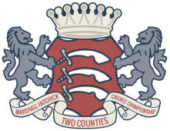

Two Counties Awards Evening – Saturday 9th November 2024 Menu

Starters
- Roasted Vine Tomato and Basil Soup (Vegan, can be GF)
- Homemade Prawn Toast served with an Asian slaw and sweet chili dip
- Gressingham Duck served in a filo basket topped with leek and cucumber and crispy pancetta drizzled with a hoisin dressing
Main Course
- Roasted Sirloin of Beef with roast potatoes, braised red cabbage, roasted carrot, tender stem broccoli, Yorkshire pudding and a beef jus (Can be GF, can be DF)
- Chicken stuffed with asparagus, wrapped in smoked bacon and puff pastry, served on a leek and cheesy mash cake with roasted root vegetables and peas, accompanied with a sparkling white wine and tarragon sauce. (Can be GF, can be DF)
- Roasted Vegetable, Mozzarella and Fresh Basil Gateau served on a carrot and potato rosti with a fresh tomato sauce (GF, Can be Vegan)
Desserts
- Raspberry Pavlova stack (GF)
- Chocolate Brownie with honeycomb and white chocolate ice cream (Can be GF, can be Vegan)
- Raspberry and Prosecco Posset served with shortbread biscuit (Can be GF)

